Upon launching the program executable file (.exe), an interface as follows will appear. Most of the fields are populated automatically as shown. Follow the four simple steps below to generate the situation report (SITREP).

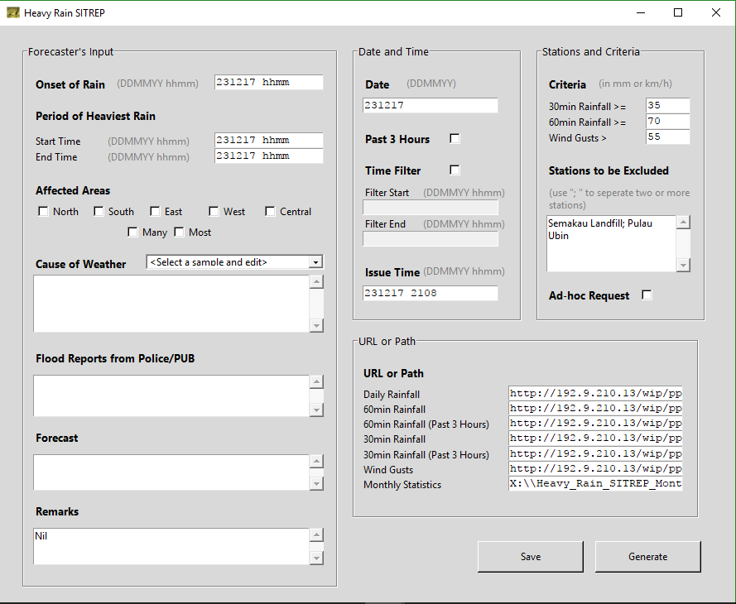

Choose a sample for the cause and edit the text to suit your assessment.

1. **Click ‘Save’ to save the input values and settings.**
2. **Click ‘Generate’ to create the SITREP**

Select ‘Time Filter’ option and specify the required temporal range. Useful when there are more than one spell in a day.

Select ‘Ad-hoc Request’ option to indicate the issuance is due to ad-hoc request by other agency(ies).

Select ‘Past 3 Hours’ option if the heavy rain spans across midnight, so that 60min and 30min rainfall data will not be reset to zero.

1. **Skip this unless changes to default settings are needed.**

All entries for time are in the format of ‘hhmm’. Use 0000 instead of 2400 for midnight.

1. **Forecaster’s assessments are to be input here.**

After **Step 4**, a SITREP in Microsoft Word (.docx) format will be saved in the folder named ‘Heavy_Rain_SITREP_Files’ located in the same directory as the program executable file (.exe). Shortcuts are available on the desktop. The SITREP generated is shown below. Unless required, forecasters do not need to make any change to it.

1. **Copy it to an SOE machine to be sent as the email body.**

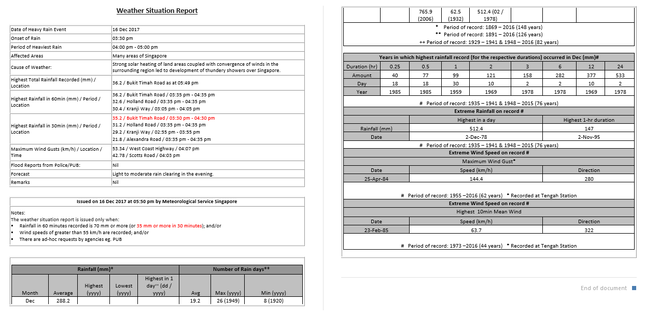

Climatological statistics of the month are appended automatically.

Font colour is changed to red automatically according to the SITREP criteria.

Rainfall and wind gusts data are selected and written automatically.

More details:

* The program runs on a 64-bit machine with Microsoft Word and Microsoft Excel installed.
* Files to be included in the same directory of the program executable (.exe) file are:
  + heavy_rain_sitrep_template.docx (compulsory)
  + heavy_rain_sitrep_defaults.ini (compulsory)
  + heavy_rain_sitrep_icon.ico (optional)
* If you wish to change the general style of the heavy rain SITREP, edit the file “heavy_rain_sitrep_template.docx”.
* If you wish to change the default settings program or default values of the SITREP criteria, etc, edit the file “heavy_rain_sitrep_defaults.ini”.
* If you wish to change the program icon, edit the file “heavy_rain_sitrep_icon.ico”.
* If the program is unable to grab data from the webpages, firstly check the URLs and the machine network connection.
* A console is opened when the GUI is launched. Check the console for debugging if necessary.